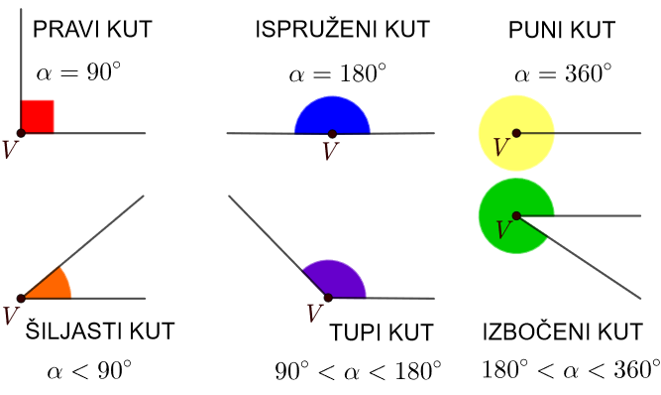

Preuzeto s: https://edutorij-admin-api.carnet.hr/storage/extracted/1875475/html/234_kut.html

